**Hope Road, Esplanade PO37 6EL**

**Falcon Cross PO37 7JY Toilets, 65 Landguard Road Office PO37 7JX & Falcon Cross Library PO37 7JP**

**Tower Cottage, Chine Avenue, PO37 6AA**

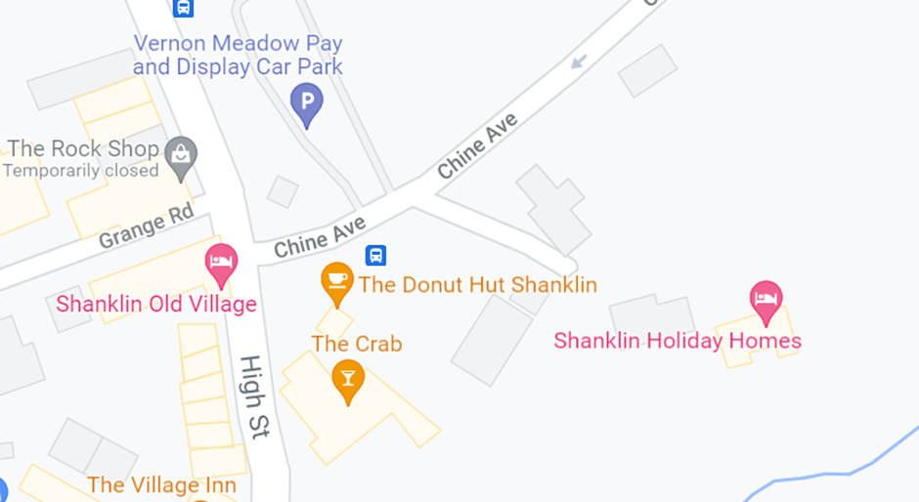

**Rylstone Gardens, Popham Road, PO37 6RG**

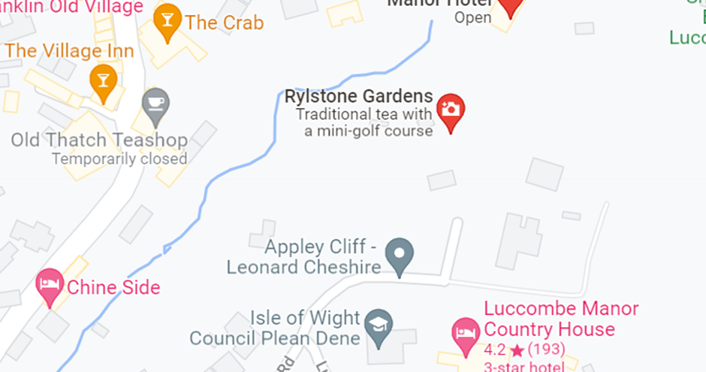

**Chine Bluff, Esplanade, PO37 6BT**

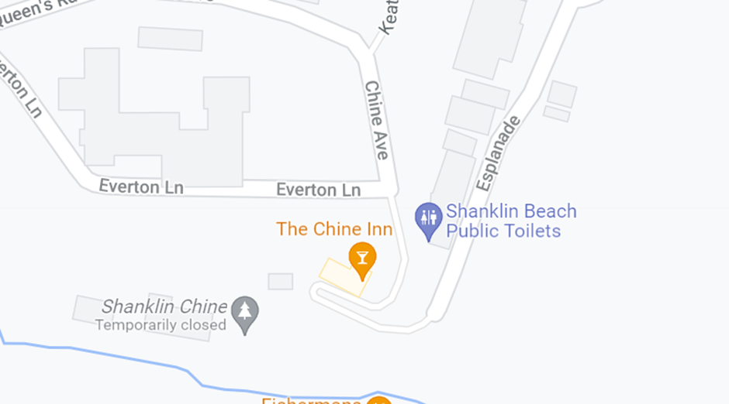



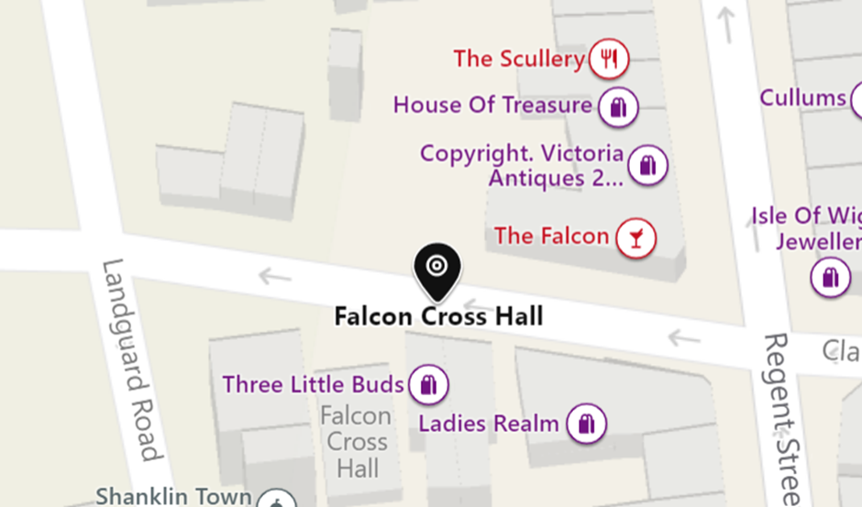

All the attached buildings are on a freehold and owned by Shanklin Town Council.