**Holiday activities and food programme (HAF)**

This summer, the Isle of Wight Council’s popular Holiday Activities and Food (HAF) programme is back — and it’s bigger, brighter and bolder than ever before.  From arts and crafts to horse riding, football to theatre skills, nature and farm animals, this year’s    line-up is bursting with activities to keep young minds and bodies active over the long summer holidays.

And let’s not forget the food! Every session includes a hot, nutritious meal — or a hearty packed lunch for day trips — with many providers encouraging children to roll up their sleeves and help prepare and serve the food themselves. It’s all part of the fun!

The HAF programme is funded by the Department for Education so that local authorities can offer healthy food and enriching activities in the school holidays to children who receive benefit-related free school meals. A small number of places are also available on HAF activities under our discretionary funding stream. Further information on HAF and eligibility can be found on the [holiday activities webpages.](https://www.iow.gov.uk/children-and-family-support/holiday-activities-and-childcare/holiday-activities/holiday-activities-and-food-programme-haf/)

**New booking system for 2025**

Booking holiday activities has never been easier. The new HAF Booking System allows families to browse and book all available activities in one convenient location. By visiting the[Eequ Booking System](https://smex-ctp.trendmicro.com/wis/clicktime/v1/query?url=https%3a%2f%2feequ.org%2fhafontheisleofwight&umid=bee772ae-457a-4246-b9e1-81e5da444fc0&auth=437a020dcc987bfc8ef77190b53d29037dc18860-ef0b0c6f38ae0ea3df99dcbbea812ac4ab0c5c56) (QR code below) users can quickly find and secure their preferred sessions, or add themselves to a waiting list if their first choice is full

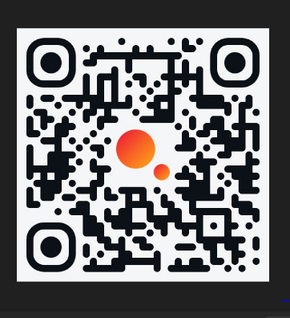

Full details on all of our activities can also be found on the Isle of Wight [Family Information Hub webpage](https://familyinfohub.iow.gov.uk/kb5/iow/directory/results.page?familychannel=8-6).

Please contact the HAF Team on [holidayactivities@iow.gov.uk](mailto:holidayactivities@iow.gov.uk) if you have any questions.